PATHSHALA NEPAL FOUNDATION

PRE-UNI PROGRAM

Baneshwor, Kathmandu



Lab assessment report on

Web Technology II (Use of JavaScript II)

**Submitted By:** **Submitted To**

Name: Raunak Raj Adhikari Department of Computer Science

Class: 12 PATHSHALA NEPAL FOUNDATION

Group: 2

Date: 2024-03-19

3. Discuss Event and Event Handeling.

4. Discuss RegEx and its use in Form Validation.

5. Define the term Object, Cookies.

6. Write JS program to.

1. Demonstrate form validation. [for null value only]

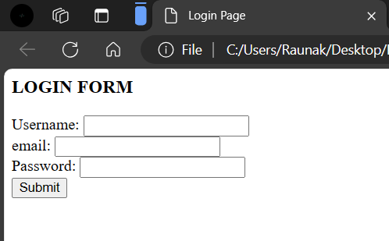 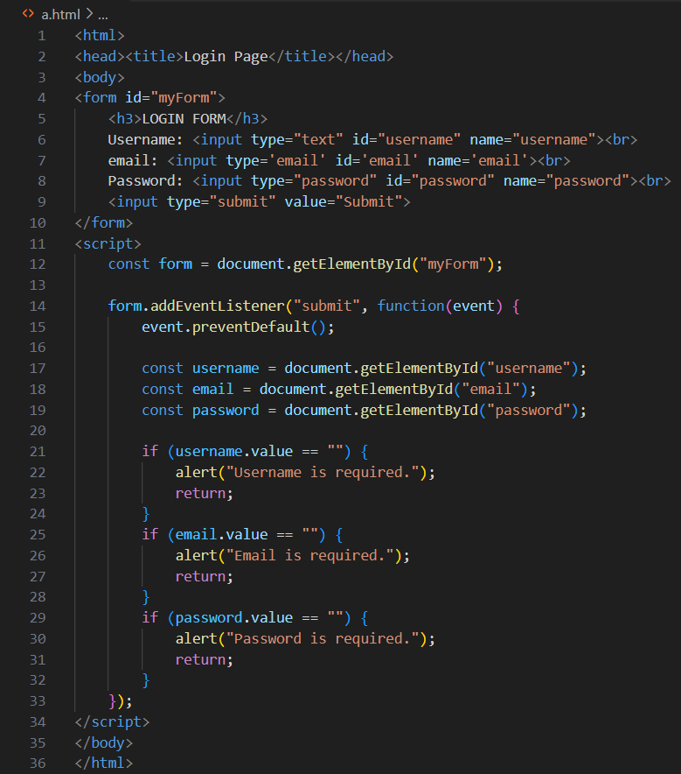

1. Design a form as given along side and check the fields as follows
   * Neither username should be blank nor length less than 12 characters.
   * Neither password should be blank nor the length below 6 and above 16.

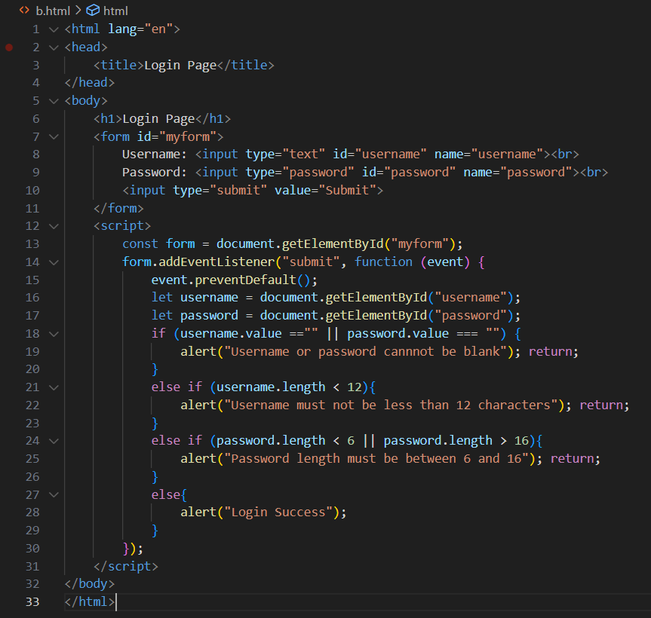  

1. Create image gallery and implement DOM and Event Handeling.

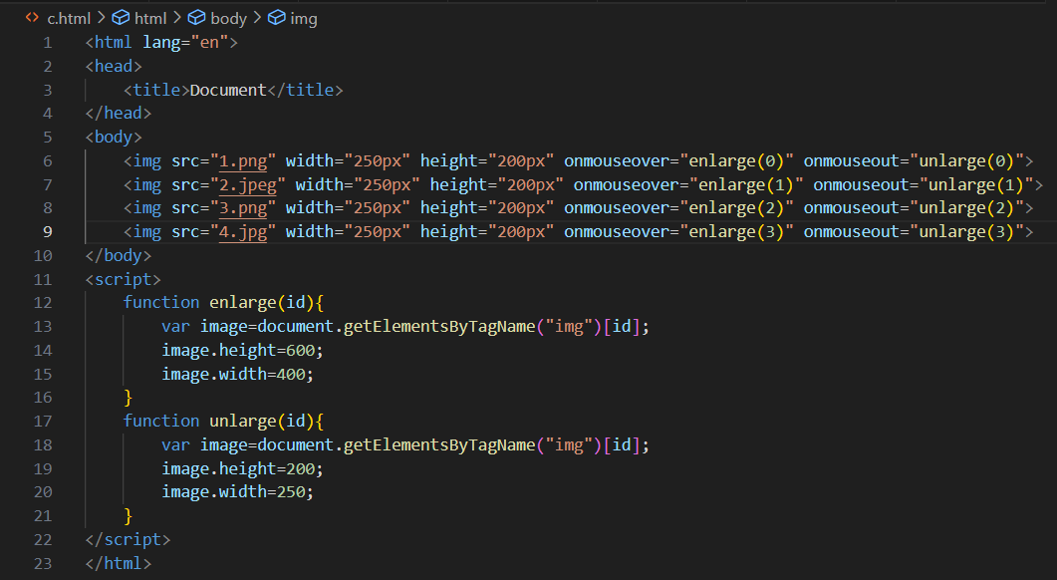 

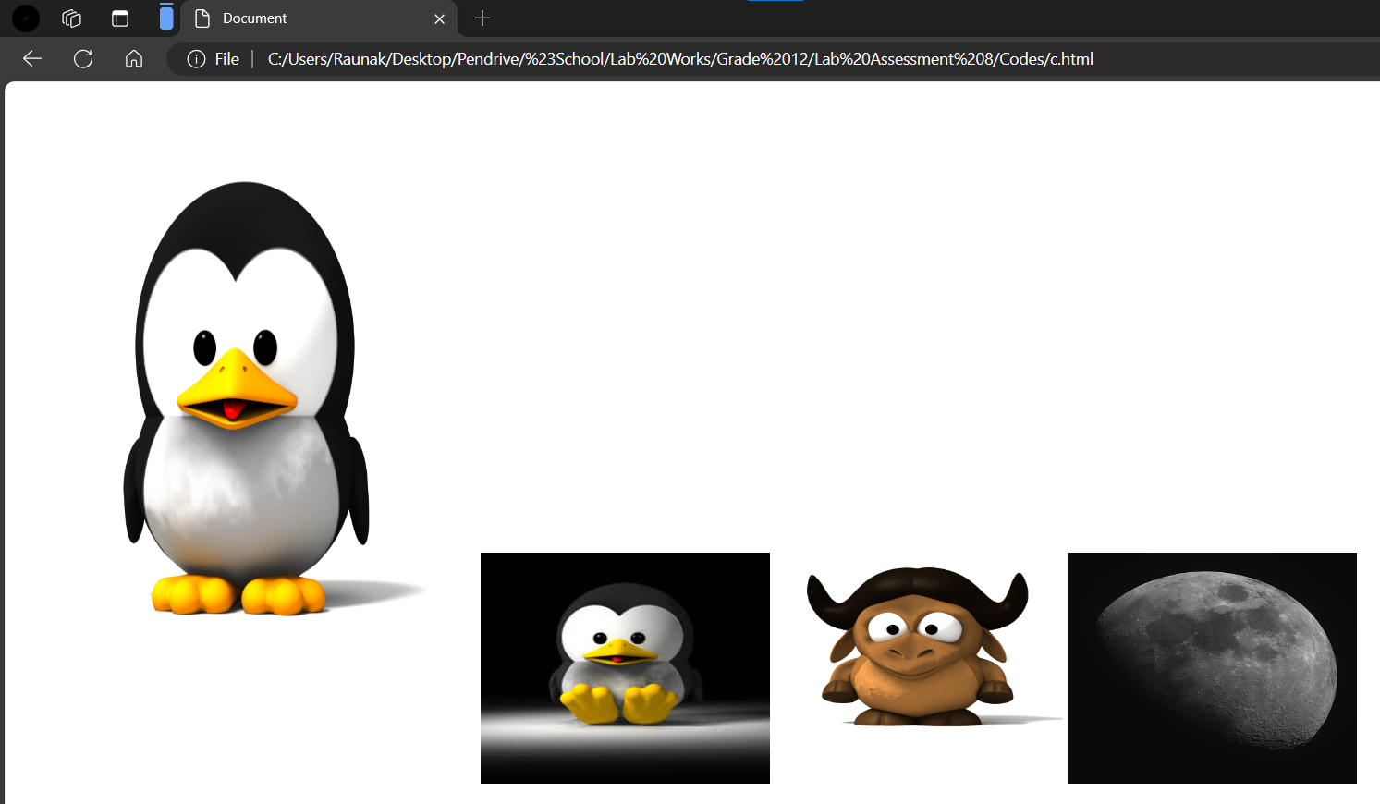

1. Prepare an HTML document with a form given alongside for conversion of temperature given in FAHRENHEIT into CELCIUS equivalent.

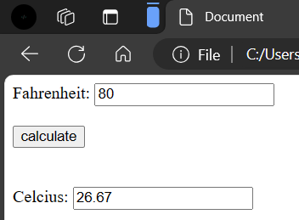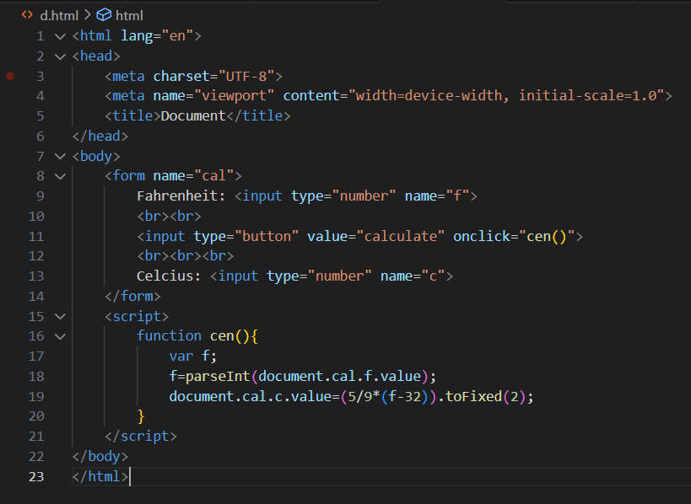

1. Prepare an HTML document to calculate simple interest for supplied principle, rate and time by folloowing the form as showin alongside. [Use JavaScript with the suitable funcation to calculate the value.]

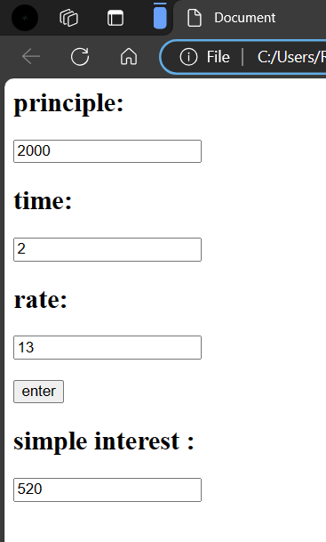 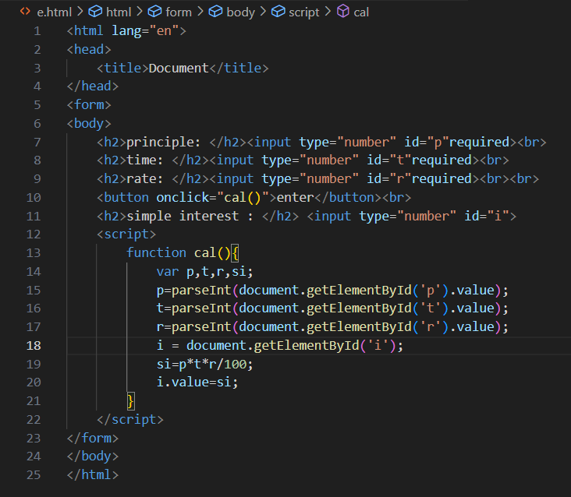

1. Prepare an HTML document to calculate sum and average of any three different numbers supplied by a user by following the form given alongside. User JavaScript with suitable functions to complete the operation.

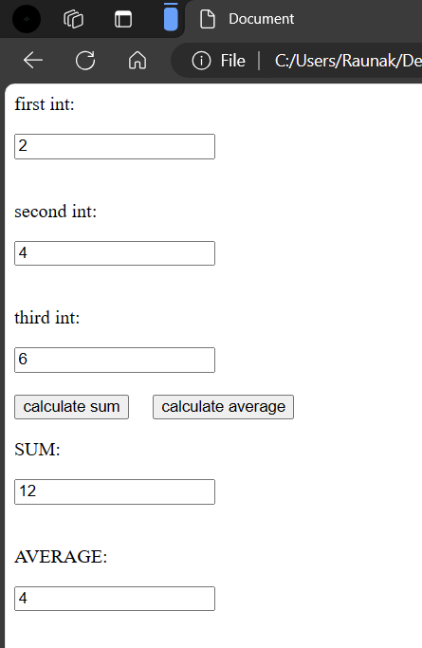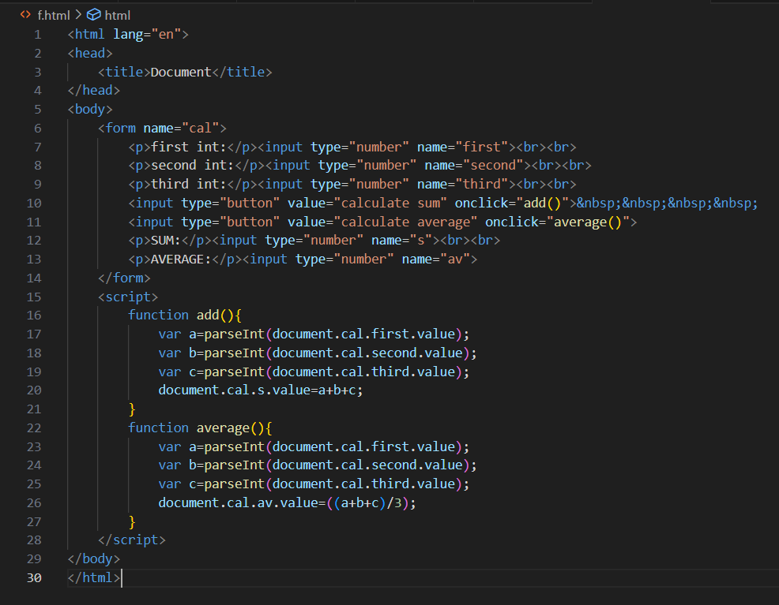

1. Prepare an HTML document to prepare a simple calculator for the calculation of sum, differentce, product, quotient and remainder etc. with asuitable form as given below: Write JavaScript code with the suitable function to perform the calculation.

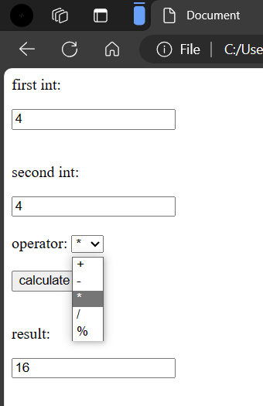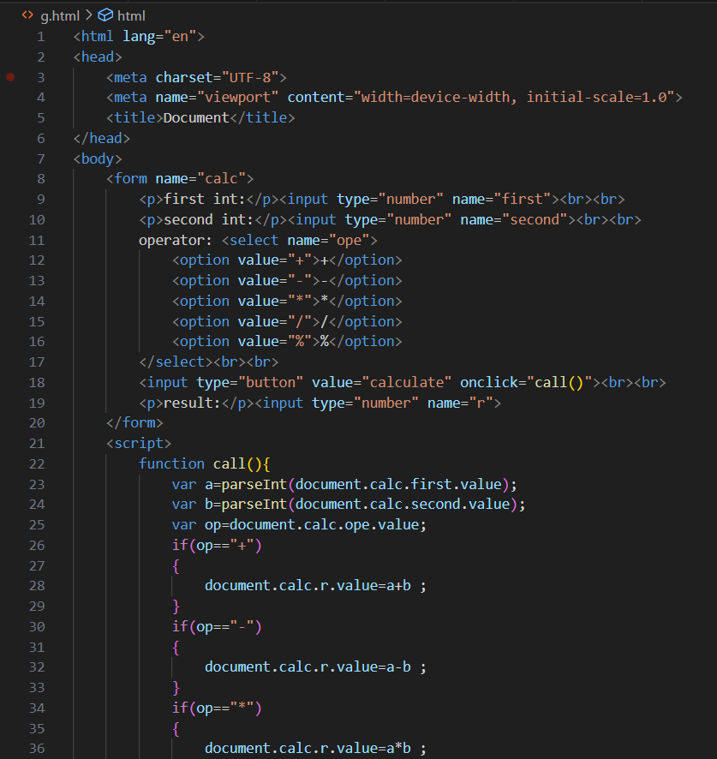 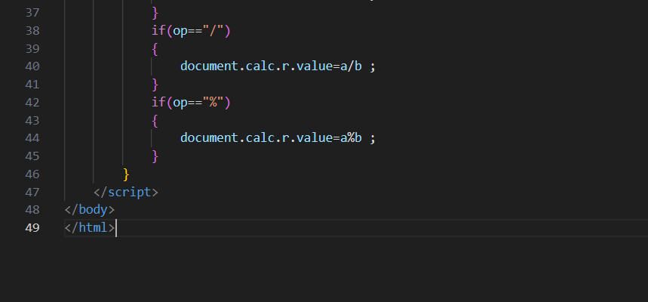

1. Develop a form as shown below to collect weekly temperature from a user and find out the maximum and minimum Temperature of the week with the suitable JS code reference.

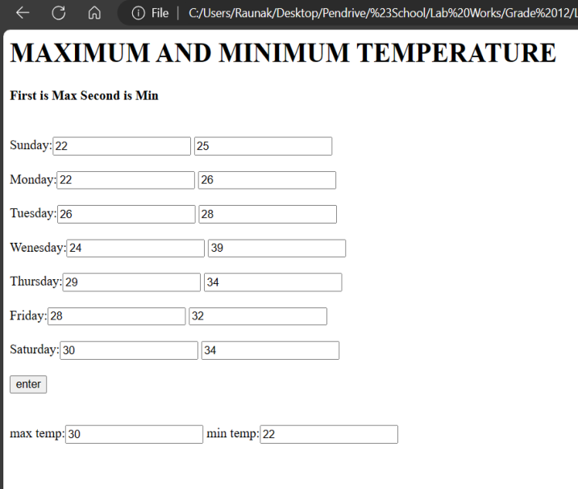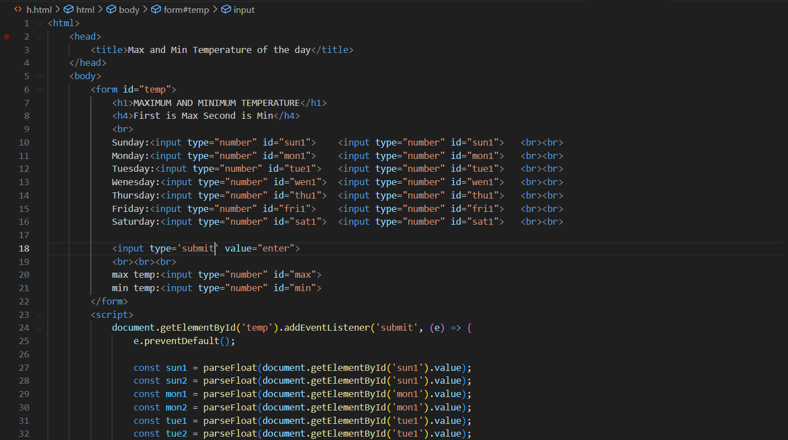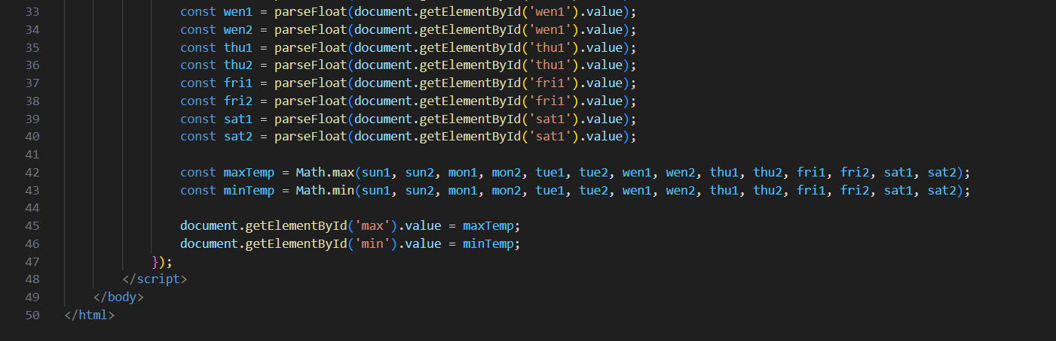

**Conclusion**

I would like to thank Mr.Suresh Sir for teaching us many things as for our better future. I have come to learn a lot from this project. This opportunity has given me indepth knowledge about Javascript.

Thank you.